P R E S S R E L E A S E

The next consistent step for NOA

Frankfurt, Germany – June 11, 2024 PI (PROFIBUS & PROFINET International) has been chosen by NAMUR and ZVEI to host NOA technology. This is consistent in two regards. On the one hand, the development of a consistent specification and certification is necessary for the step from previously developed use cases and initial test systems to interoperable applications. On the other, PI has decades of experience with precisely this task, making it the right partner from the start.

A corresponding contract which forms the basis for additional steps, such as the establishment of joint working groups, has also been concluded between NAMUR, ZVEI and PI. Thanks to the comprehensive examination and development of use cases, it’s a good basis for getting started with specification work and international standardization.

ZVEI’s Felix Seibl, Executive Director of the measurement technology and process automation department:
“With NOA, NAMUR initiated a fantastic digitization concept. We are proud that ZVEI and many of its member companies took part in further development. Our NOA-capable products make it easier for our customers in the process industry to access the stranded data in their systems in an easy and reliable way and to utilize new monitoring and optimization functions in the future. Like the MTP concept for modular systems, NOA is not necessarily “German,” even though it was initiated by NAMUR and ZVEI. Most initiators are internationally active and will utilize the NOA concept in systems across the globe. We are pleased to have found a future host organization for NOA in PI—an organization with many years of expertise and an international network. We are certain that NOA will continue on its path of success and achieve global acceptance.”

Christine Oro Saavedra, Managing Director of NAMUR:

"Thanks to close cooperation between NAMUR, PNO and ZVEI, the introduction and further development of NOA-based solutions are being moved forward to meet the needs of the process industry for open and standardized automation solutions. As users, this will enable us to benefit from greater flexibility, interoperability and future-proofing. For the digital sovereignty of our companies, NOA is the standard interface for securely connecting highly available process automation with data spaces like Process-X. This enables us to efficiently utilize use cases over the entire life cycle of our systems—an important component of our competitive capacity."

PI offers a comprehensive technology portfolio for process automation. The integration of Ethernet APL into PROFINET has been specified, and the first devices have been certified and put into use. The process automation profile creation of various devices is complete, and corresponding certifications have already been made here as well. PI is an active partner of FDI and PA-DIM. MTP activities were initiated in the middle of last year, and the first specification documents will be approved soon. The marketing of MTP has started.

Specification work for the implementation of NAMUR recommendations on NOA will begin soon—recommendations which fit perfectly into PI’s strategy for expanding its technology portfolio for the digitization of industrial production from the field level to the company-management level.

Marketing activities for the early establishment of NOA technology on the market will also begin. In addition, the global PI community—which already has a wide variety of experience in process automation—will be trained in the technology and active in marketing.

“Thank you for trusting us to host NOA technology. It enables us to support the next step in the successful establishment of NOA with manufacturers and users,” said Xaver Schmidt, Chairman of the Board of PI. “To us, this is also confirmation of the work and portfolio elements for the process automation market which have already been carried out and implemented— our contribution to solving the challenges of process automation.”
***
Graphic: The NOA architecture is the basis for additional data.

Fotos: Felix Seibl (ZVEI) and Christine Oro Saavedra (NAMUR) are looking forward to the next step in establishing NOA.
Christine Oro Saavedra (NAMUR)
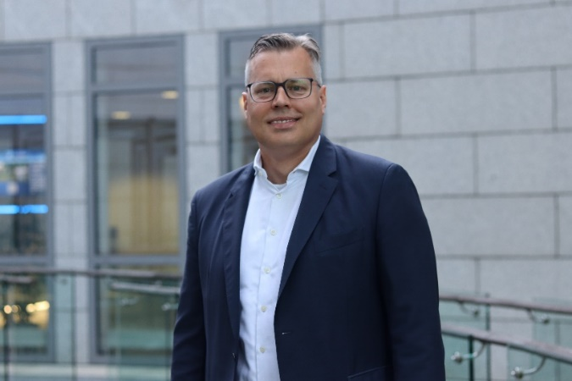
Felix Seibl (ZVEI)

Press contact:
PI (PROFIBUS & PROFINET International)
PROFIBUS Nutzerorganisation e. V.
Barbara Weber

Ohiostr. 8

D-76149 Karlsruhe, Germany
Phone: +49 7 21 986197 49

Fax: +49 7 21 986197 11
Barbara.Weber@profibus.com
http://www.PROFIBUS.com

