P R E S S R E L E A S E

The Future of Ethernet in Process Automation Starts Now!
The largest demonstration model for PI technologies in process automation

Karlsruhe, Germany – June 11, 2024: At this year’s ACHEMA trade show, the seamless and manufacturer-independent integration of PROFINET and PROFIBUS technologies into the process industry world will be impressively demonstrated at Stand C4 in Hall 11.0. The largest process automation (PA) live demo wall will be on display in Frankfurt (Germany) for this very purpose. A total of 68 devices from 19 manufacturers—featuring the latest integration option, PROFINET over APL, in some cases—will be integrated into the wall, among other things. A wide range of applications from the field of process automation will also be presented on the demo wall, and the advantages for the process industry offered by PI technologies will be clearly demonstrated as well.
Connecting classic devices to PROFINET
Without a doubt, PROFINET is the top-performing communication solution for data transfer in process automation, but not all field devices and systems in plants support direct connection yet. Despite this, the successful start in the world of PROFINET will be impressively presented on the PA demo wall, regardless of whether it is devices with conventional 4 to 20 mA technology, classic 2-wire fieldbus PROFIBUS PA or PROFIBUS DP or devices with modern Ethernet APL technology.
Ethernet APL down to the field level
Ethernet APL enables Ethernet down to the field level in process automation. The first field devices and field switches with a PROFINET over APL interface had already been presented shortly following adoption of the Ethernet APL specification. Since then, many other manufacturers have joined in to demonstrate the potential of Ethernet APL for use in new systems and system expansions on the PA demo wall.

Manufacturer-independent automated device swapping
An explanation of how automated device swapping is implemented—even from different manufacturers, if necessary—will also be provided. With PA Profile 4 for PROFINET, a new device need only be connected to the same port as the old device. The core configuration of the old device can be used and transferred to the new device here. Compared to the complex procedure involved with 4 to 20 mA technology with HART, device swapping is dramatically simplified.
Maximum safety with PROFIsafe
The technology demonstrator for a PROFIsafe application based on devices with a PROFINET over APL interface is also highly anticipated. PROFIsafe is a TÜV-tested SIL3 safety protocol based on the black-channel principle which ensures maximum plant availability. This technology demonstrator will not be the only thing providing insight into how flexible, yet safe, process automation will look in the future. Users in the process industry field not only benefit from PI technologies by increasing the efficiency of their plants, but also by reducing the amount of maintenance and service required.

***

Graphic: Thanks to automated device swapping with PA Profile 4.0, the complex procedure for swapping devices is dramatically simplified.
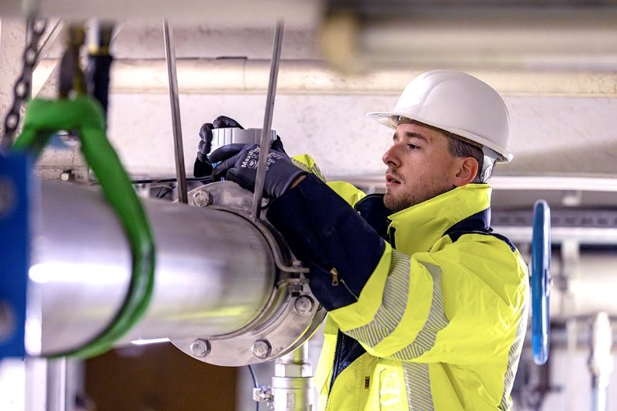
Copyright: Endress+Hauser

Press contact:
PI (PROFIBUS & PROFINET International)
PROFIBUS Nutzerorganisation e. V.
Barbara Weber

Ohiostr. 8

D-76149 Karlsruhe, Germany
Phone: +49 7 21 986197 49

Fax: +49 7 21 986197 11
Barbara.Weber@profibus.com
http://www.profibus.com

