P R E S S R E L E A S E

PROFINET Security Class 1 Plugfest 2024
Interoperability for secure real-time communication

Karlsruhe, Germany – June 24, 2024: Already some time ago, PI (PROFIBUS & PROFINET International) committees began working on OT security because of its supreme importance regarding digitization and the associated data collection. Step-by-step specifications, proofs of concept and guidelines were developed by technical working groups.

Now, the first PROFINET Plugfest event focusing on security took place at the SmartFactoryOWL—a joint institution of the OWL University of Applied Sciences and Arts and the Fraunhofer Institute—in Lemgo, Germany on June 12 and 13, 2024. PROFINET Plugfests were established as events where new functions in controllers, devices and certification could be tested with one another at an early stage. This being the case, attendees included leading manufacturers and developers of the certification system.

A focal point of this year’s Plugfest in Lemgo was Security Class 1, which improves upon the basic security features of the SNMP and DCP protocols used with PROFINET. The importing of signed GSD files was also highlighted at the Plugfest. This made it possible to also take advantage of the get-together to test interoperability of the RSI (Remote Service Interface) protocol, which enables complete Ethernet layer 2 communication by PROFINET.

Every possible cross-manufacturer controller and field device combination was tested successfully. As well, the exchange of experience between developers during the event and the networking that followed made a valuable contribution to the quality of security integration into PROFINET products and the shared understanding of the community. Against the backdrop of this success, the next Security Plugfest—for Classes 2 and 3—has already been scheduled for late 2024.

The recent Plugfest was hosted by the Fraunhofer Institute in Lemgo. The special laboratory infrastructure of the SmartFactoryOWL contributed significantly to the success of the Plugfest. Participants were able to experience the areas of research and technological solutions through live presentations there - including among other the topics of AI, 5G and localization.

***

Image: Developers of technological components, device manufacturers and certification experts met at the first-ever PROFINET Security Plugfest at the SmartFactoryOWL in Lemgo.

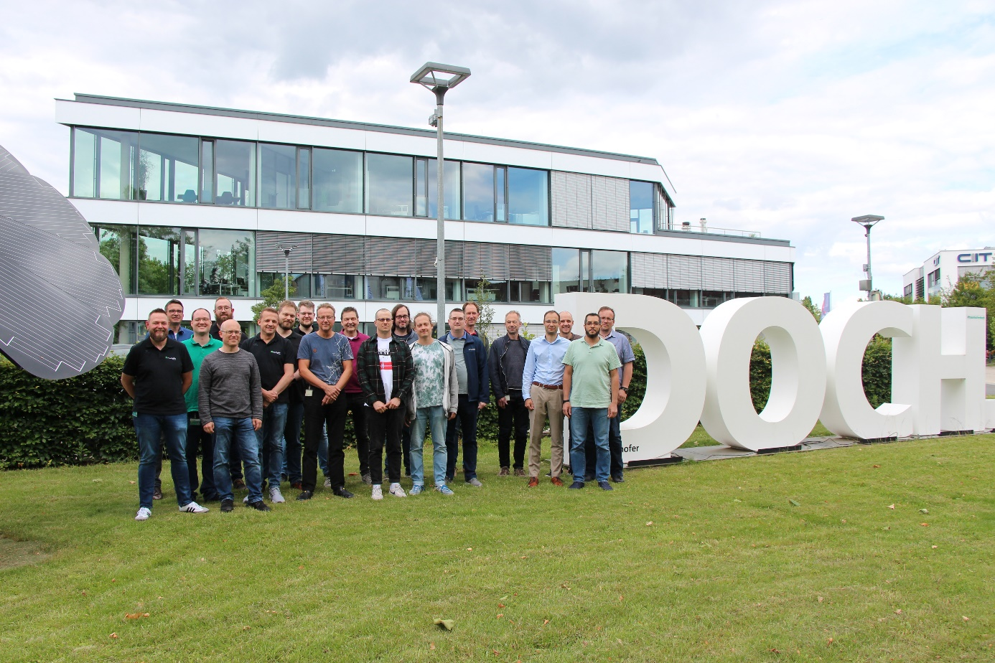

Press contact:
PI (PROFIBUS & PROFINET International)
PROFIBUS Nutzerorganisation e. V.
Barbara Weber

Ohiostr. 8

D-76149 Karlsruhe, Germany
Phone: +49 7 21 986197 49

Fax: +49 7 21 986197 11
Barbara.Weber@profibus.com
http://www.PROFIBUS.com

