P R E S S R E L E A S E

Second IO-Link Test Laboratory in China
IO-Link technology has massive growth potential in China

Karlsruhe, Germany – July 03, 2024: In late May of this year, China-based Nanjing Loyst Industrial Networks Co., Ltd. was officially recognized as a new IO-Link test laboratory. “We’re pleased to have increased the number of IO-Link test labs around the world to four thanks to Loyst,” commented Frank Moritz, Member of the Board of Directors of PROFIBUS & PROFINET International (PI). Loyst is one of the most active members of IO-Link China and the second test laboratory outside of Germany.
IO-Link competence centers and test labs not only assist in spreading IO-Link technology, but also ensure the high quality of IO-Link devices. While competence centers advise users, manufacturers and potential new members on organizational and technological issues, the test labs conduct conformity tests on IO-Link devices and IO-Link masters. Loyst is now authorized to conduct IO-Link tests independently and enable manufacturer declarations based on the test reports,” explained Moritz.
Massive potential for IO-Link technology in China
IO-Link is attracting growing interest in Asia—especially in China, where there are now over 100 members of the IO-Link community. The introduction of IO-Link has been taking place over the past few years, in particular in the automotive and energy industries. The proportion of device manufacturers in the IO-Link community grew as a result, as did the number of conformity tests required. The approved IO-Link test laboratory in China now makes it possible for Chinese manufacturers to launch their products on the market faster and more easily.
Two specialists from China traveled to the IO-Link Test Center TMG TE in Karlsruhe, Germany, for the final approval. The acceptance was carried out by the two established Test Laboratories—TEConcept (represented by Dr. Franz-Otto Witte) and TMG TE (represented by Klaus-Peter Willems)—as well as the head of the IO-Link Quality Working Gup, Frank Moritz (PI/Sick). The way that conformance testing of both IO-Link devices and IO-Link masters would be implemented in practice was first discussed in a theoretical part. At its disposal, Loyst has testing systems from TEConcept which have been approved by the IO-Link community.
Loyst was able to demonstrate that it could properly conduct the tests using an IO-Link device and an IO-Link master specially prepared for the audit. Two years prior to being approved as a test center, Loyst became an authorized competence center. “Just like back then, the specialists at Loyst were well prepared and capable of conducting every task smoothly,” said Frank Moritz in summary. With this, Nanjing Loyst verified its in-depth knowledge of IO-Link and compliance with the test center guidelines of the IO-Link community, enabling it to serve as an approved test laboratory.

***

Photo: Loyst is the IO-Link Community’s second IO-Link test laboratory in Asia. Presentation of the official document to the two specialists from China is shown here (from left to right: Franz-Otto Witte, Li Bo, Frank Moritz, Wang Jun and Klaus-Peter Willems).
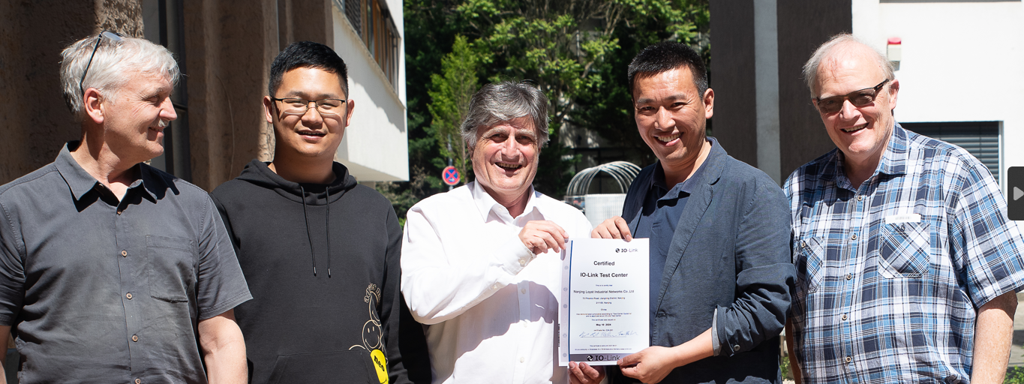

Press contact:
PI (PROFIBUS & PROFINET International)
PROFIBUS Nutzerorganisation e. V.
Barbara Weber

Ohiostr. 8

D-76149 Karlsruhe, Germany
Phone: +49 7 21 986197 49

Fax: +49 7 21 986197 11
Barbara.Weber@profibus.com
http://www.PROFIBUS.com

